KiCad Step by Step Tutorial
Copyright © 2006 David Jahshan: kicad at iridec.com.au
2011 Update Copyright © 2011 Phil Hutchinson

Copyright: Please freely copy and distribute (sell or give away) this document in any format. Send any corrections and comments to the document maintainer. You may create a derivative work and distribute it provided that:
1. If it's not a translation: Email a copy of your derivative work to the author.
2. License the derivative work in the spirit of the GPL. Include a copyright notice and at least a pointer to the license used.
3. Give due credit to previous authors and major contributors.
If you're considering making a derived work other than a translation, it's requested that you discuss your plans with the current maintainer.
Disclaimer: While care was taken in preparing this document, there are likely a number of errors. Please let the author know about them. Since this is free documentation, the author will not be held legally responsible for any errors.
Trademarks: Any brand names should be assumed to be a trademark. Such trademarks belong to their respective owners.

KiCad is a open source (GPL) integrated package for schematic circuit capture and PCB layout.
Before you start, you will need an installed copy of KiCad. This tutorial assumes that KiCad is installed at C:\Kicad. You can download a copy from http://www.lis.inpg.fr/realise_au_lis/kicad/
Installation instructions are available on the web site under Infos:Install

- Run “KiCad.exe”.
- You are now in the main window:
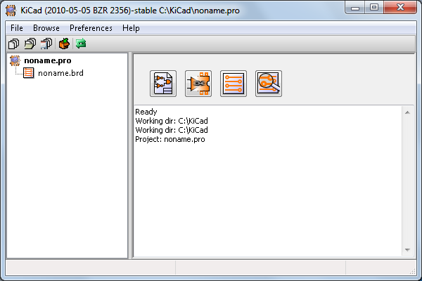
- Create a new project: “File” -> “New”
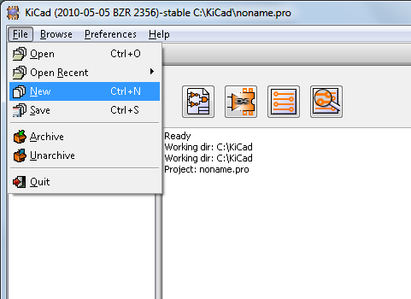
- Click on the “New Folder” button, and name the new folder “tute1”.
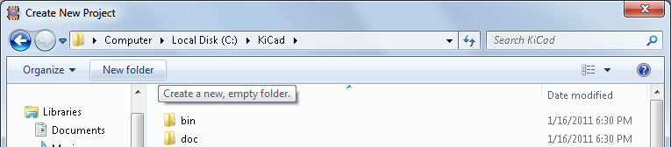
- Open the new folder by double clicking on it.
- Enter the name of the project in “File name”. In this tutorial we will call it “tute1”.
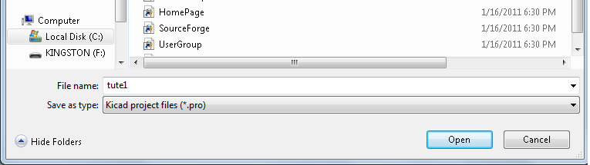
- Click “Open”. You should notice the project name should change to “tute1”.
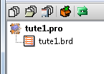
- Click the Schematic editor button
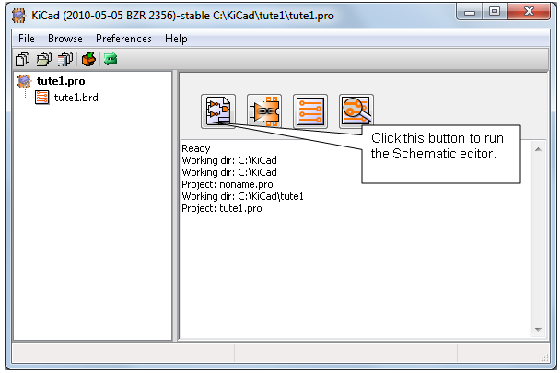
- In the error dialog that appears telling you that the file was not found, click “OK”.
- You are now in the “EESchema” window. This window is used for entering schematics.
- You should first save the schematic project: “File” -> “Save Whole Schematic Project”.
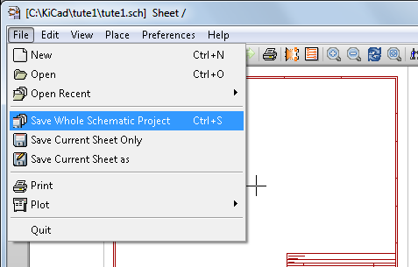
- Click the “page settings” button on the top toolbar.
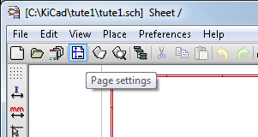
- Select the “Page Size” as “A4” and enter the “Title” as “Tute 1”. Click “OK”.
- In the EESchema window, click on the “Add components” button found in the right toolbar.
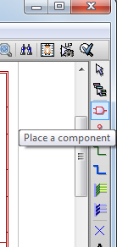
- Click in the middle of the red box in the editing window to place your first component.
- A “Component selection” window will appear.
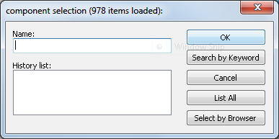
- Click on “List All”. The “Select Lib” window will appear.
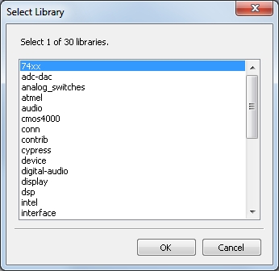
- Double click on the “device” library.
- The “Select Component” window will appear.
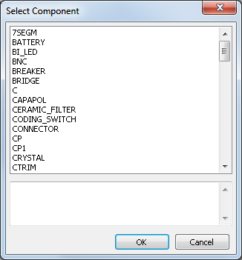
- Scroll down and double click on “R”. This will close the “Select Component” dialog and place component “R” onto your schema.
- Place the component in the middle of the sheet by left clicking where you want it.
- Click on the magnifier several time to zoom in on the component.
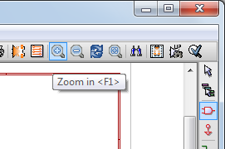
- Hover the mouse over the component and press 'r' on the keyboard. Notice how the component rotates.
- Right click in the middle of the component and select “Edit Component” -> “Value”
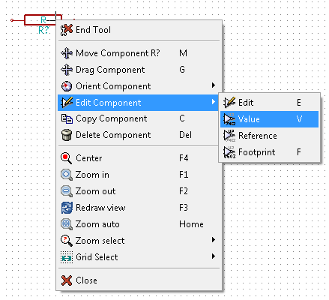
- The “Component value” window will appear.
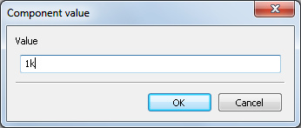
- Replace the current “Value” “R” with “1k”.
- Click “OK”.
- The value inside the resistor should now be “1k” .
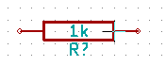
- To place another resistor, click on the place you want the resistor to appear.
- The “Component selection:” window will appear.
- The resistor you previously chose is now in your history list appearing as “R”.
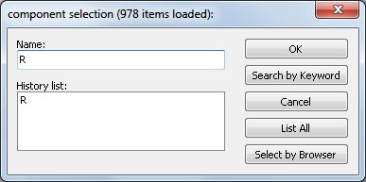
- Click on “R”.
- Place the resistor on the page
- Repeat and place a third resistor on the page.
- Right click on the second resistor and click on “Delete Component”. This will remove the component from the schematic.
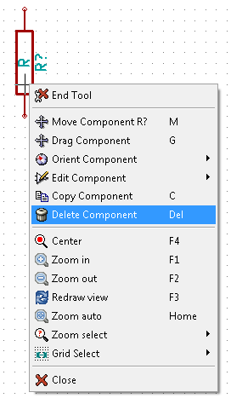
- Right click on the third resistor. Select “Move Component”.
- Reposition the component and left click to drop.
- Repeat steps 24 to 27 on the third resistor and replace “R” with “100”
- Repeat steps 14 to 20, however this time select the “microcontrollers” library instead of the “device” library and the “PIC12C508A” component instead of the “R” component.
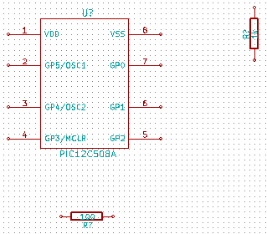
- Hover the mouse over the microcontroller component. Press 'y' and 'x' on the keyboard. Notice how the component is mirrored on its x and y axes. Press 'y' and 'x' again to return it to its original orientation.
- Repeat steps 14 to 20, however this time choose the “device” library and the “LED” component.
- Organise the components on the page in the following way:
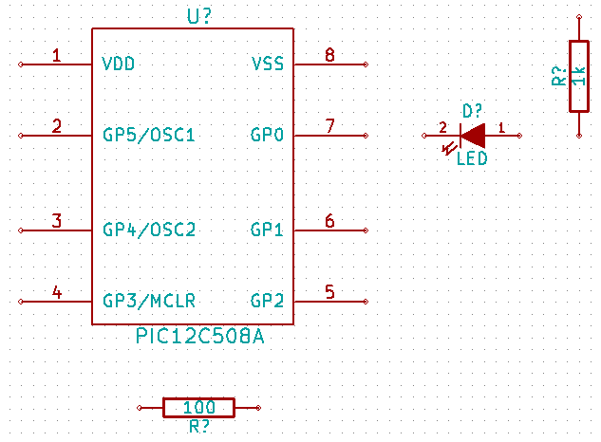
- Sometimes a component that you want to place on your schematic isn’t in your component libraries. We will now add a new component to the library.
- Click on the “go to library editor” button on the top toolbar.
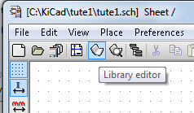
- This will open the “Component Library Editor” window.
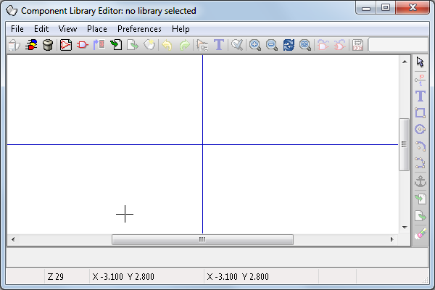
- Click on the “Select working library” button.
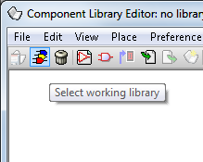
- In the “Select Library” window click on “conn” and click “OK”.
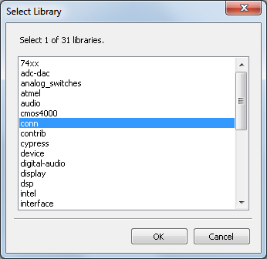
- Click on the “New component” button.
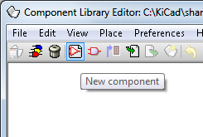
- The Component Properties window will appear.
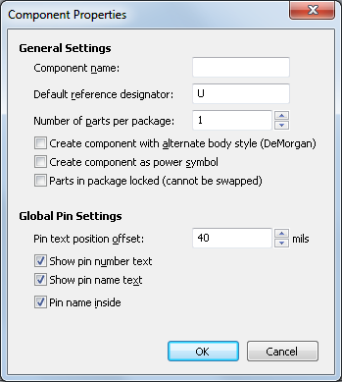
- Name the new component “MYCONN3”. Enter the “Default reference designator” as “J”, and the “Number of parts per package” as “1”.
- Click “OK”
- If the warning “has a convert drawing” appears click “yes”.
- In the middle of the screen the name of the component will appear. Click on the magnifier a few times to zoom in on it.
- Click on the “Add Pins” button on the right toolbar.
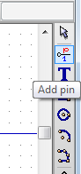
- Left click on the part editor screen just below the “MYCONN3” label.
- In the “Pin Properties” window that appears, enter pin name as “VCC”, enter the pin number as “1”, and select “Electrical type” as “Power output” then click “OK”.
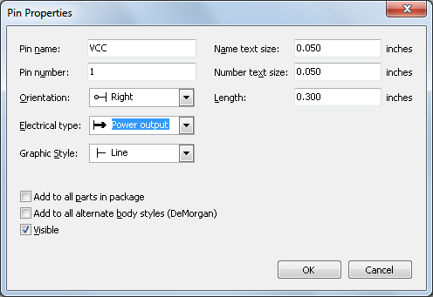
- Place the pin by clicking at the location you would like it to appear, right below the “MYCONN3” label.
- Repeat steps 55 to 57. This time, “Pin name” should be “INPUT”, 'Pin number” should be “2”, and “Electrical Type” should be “Power input”.
- Repeat steps 55 to 57. This time “Pin name” should be “GND”, “Pin number” should be “3”, and “Electrical Type” should be “Power output”.
- Arrange the pins like this:
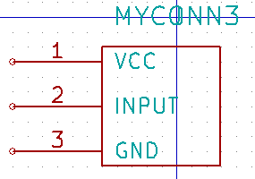
- Click on the “Add rectangle” button.
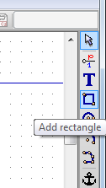
- We want to draw a rectangle around the pins, as is seen below. To do this, click and release the left mouse button where you want the top left corner of the rectangle to be. Then move your mouse to where you want the bottom right rectangle corner to be and again click the left button.
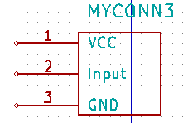
- Click on “Update current component in current library” on the top toolbar.
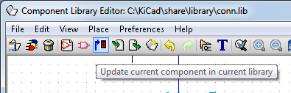
- Click on “Save current loaded library on disk (file update)” on the top tool bar.
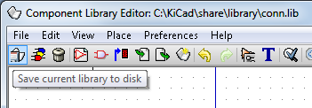
- Click “Yes” in any confirmation messages that might appear.
- You can now close the “Component Library Editor” window. You will be returned to the EESchema window.
- Repeat steps 14 to 20, however this time choose library “conn” and component “MYCONN3”.
- Your newly created part will appear. Choose a location near the second resistor to place this component. Press the 'y' key to mirror it on the y axis.
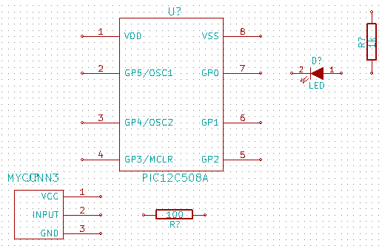
- The component identifier “J?” will appear under the “MYCONN3” label. Right click on “J?” and click on “move field”. It might be helpful to zoom in a bit before doing this. Reposition “J?” to under the pins.
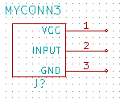
- Click on the “Add powers” button on the right toolbar.
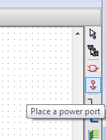
- Click above the pin of the 1k resistor.
- In the “Component selection” window, click the List All button.
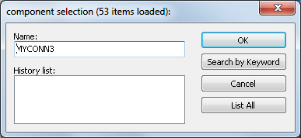
- Scroll down and select “VCC” in the “Select Component” window. Click OK.
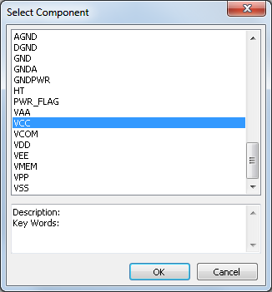
- Click above the pin of the 1k resistor to place the part.
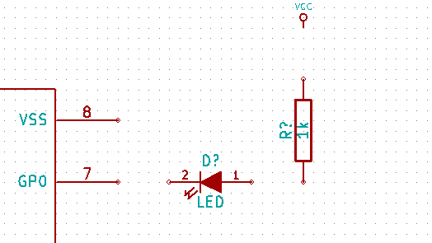
- Click above the VDD pin near the microcontroller.
- In the “Component Selection history” select “VCC” and click again next to the VDD pin.
- Repeat again and place the VCC pin above the VCC pin of “MYCONN3”.
- Repeat steps 70 to 72 but select GND this time.
- Place a GND pin under the GND pin of “MYCONN3”.
- Place another GND symbol a little to the right and below the VSS pin of the microcontroller. Your schematic should look something like this:
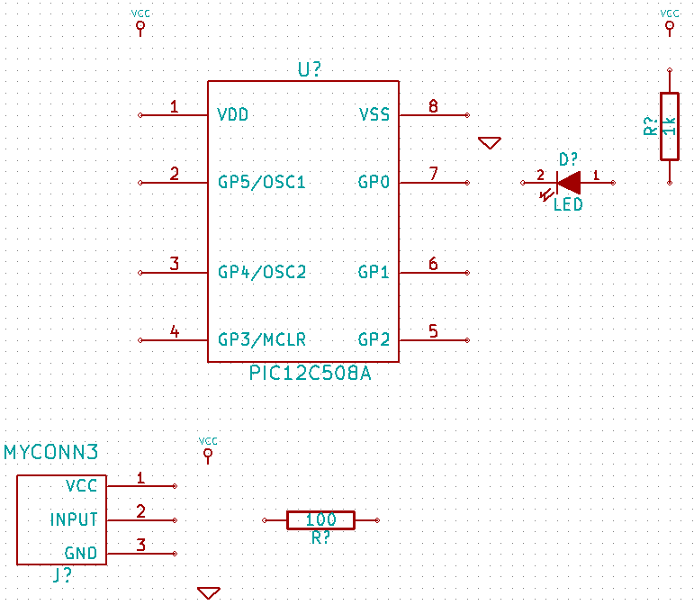
- Click on the “Place a wire” button on the right toolbar. **Be careful not to pick “Place a bus” which appears directly beneath this button but has thicker lines**.
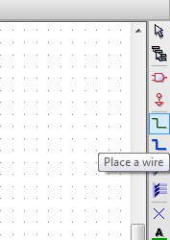
- Left click on the little circle on the end of pin 7 of the microcontroller and then on the little circle on pin two of the LED.
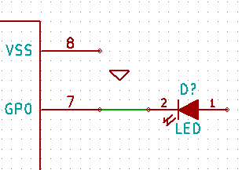
- Repeat this process to wire up the other components as below. To terminate a wire that isn’t connected to anything, double-click the left mouse button. When wiring up the VCC and GND symbols, the wire should touch the bottom of the VCC symbol and in the middle top of the GND symbol.
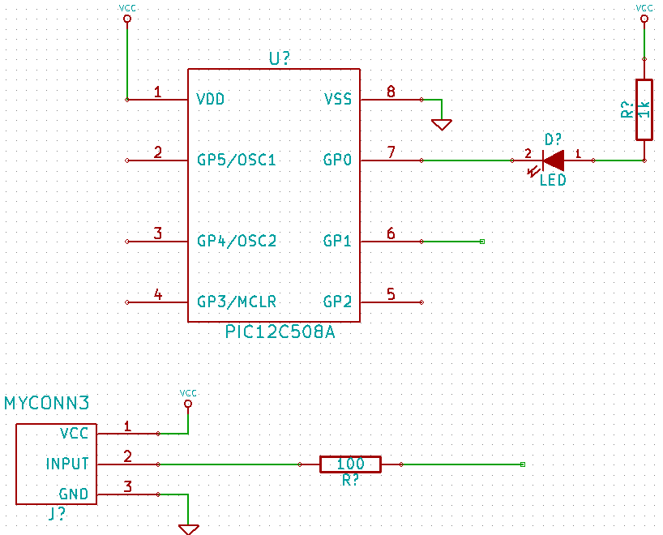
- Label the nets by clicking on the “Place net name” button on the right toolbar.
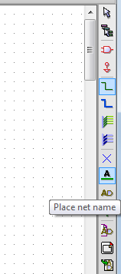
- Click in the middle of the wire between the microcontroller and the LED.
- Enter the name “uCtoLED”.
- Click near the circle (little to the right) of pin 7 to place the net name.
- Name the wire between the resistor and the LED to “LEDtoR”.
- Name the wire between “MYCONN3” to the resistor as “INPUTtoR”.
- Name the line on the right of the 100 ohm resistor as “INPUT”.
- Name the line from pin 6 as “INPUT”. This creates an invisible connection between the two pins labelled “INPUT”. This is a useful technique when connecting wires in a complex design where drawing the lines would make the drawing very messy.
- You do not have to label the VCC and GND lines, the labels are implied from the power objects they are connected to.
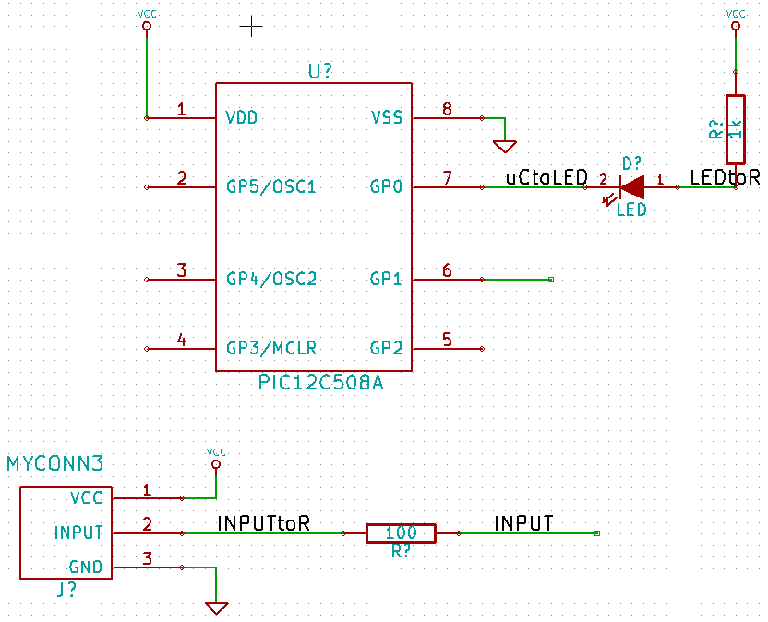
- The program checks for wiring errors. Any wires that are not connected may generate a warning. To avoid these warnings you can instruct the program that the unconnected wires are deliberate.
- Click on the “Place no connect” flag button on the right toolbar.
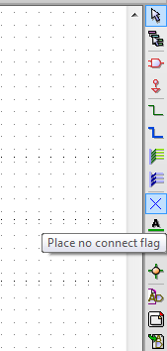
- Click on the little circle at the end of lines 2, 3, 4 and 5. X’s will appear to signify that the lack of a connection is intentional.
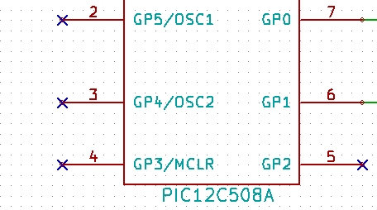
- To add comments on the schematic use the “Place graphic text (comment)” on the right toolbar.
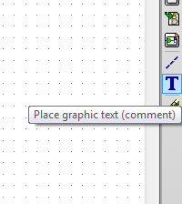
- The components now need to be given unique identifiers. To do this click on the “Annotate schematic” button.
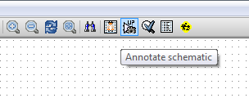
- In the “Annotate Schematic” window, select “Use the current page only” and click the “Annotation” button.
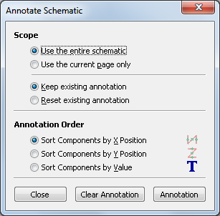
- Click “OK” in the confirmation message and then click “Close” in the “Annotate Schematic” window.
- Notice how all the “?” on the components have been replaced with a number. Each identifier is unique. In our example “R1”, “R2”, “U1”, “D1” and “J1”.
- Click on the “Schematic Electric Rules Check” button. Push the “Test ERC” button in the window that appears.
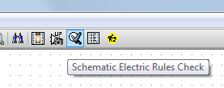
- This will generate a report to inform you of any errors or warnings such as wires being disconnected. You should have 0 Errors and 0 Warnings. A small green arrow will appear in the location of the error if you have made a mistake. Check “Write erc report” and press the “Test ERC” button again to receive more information about the errors.
- Click on “Netlist generation” on the top toolbar.
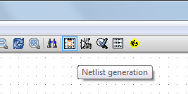
- Click “Netlist” then on “save” to the default file name.
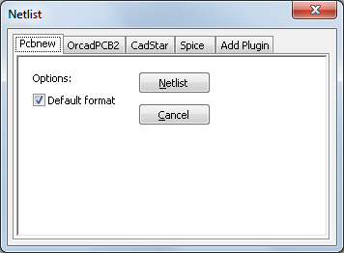
- Click on “Run Cvpcb” on the top toolbar.
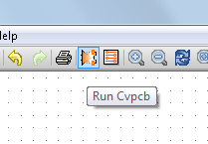
- Click OK if an error appears about not being able to open a component library.
- Cvpcb permits you to link footprints to components. In the pane on the left, select “D1”. In the pane on the right, scroll down to “LEDV” and double click on it.
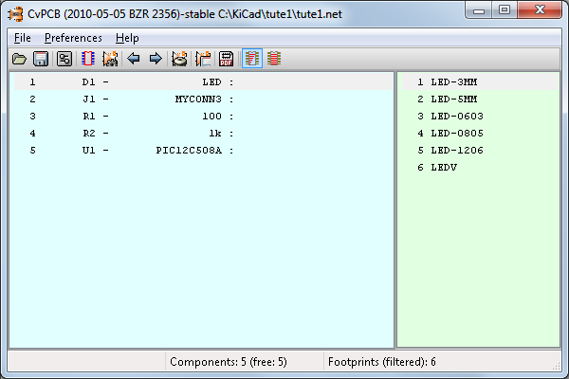
- For “J1” select the “3PIN_6mm” footprint.
- For “R1” and “R2” select the “R1” footprint from the light green screen.
- Select “DIP-8__300” for “U1”.
- Click on “File”->”Save As”. The default name “tute1.net” is fine, so click save.
- Back in the schema editor, save the project by clicking on “File” -> “Save Whole Schematic Project”.
- Switch to KiCad main window.
- Select “Browse” -> “View File”.
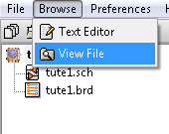
- If an error message appears, choose your text browser. Most Windows computers have one at “c:\windows\system32\notepad.exe”.
- Select the “tute1.net” file. This will open your netlist file. It describes which components and which pins are connected to which pins.
- Close your text editor and return to the “EESchema” window.
- To create a bill of materials, click on the “Bill of materials” button on the top toolbar.
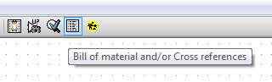
- Click “OK” and then “Save”.
- To view the file repeat steps 113-115 and select “tute1.lst”.
- Close the text editor.
- Now click on the “Run Pcbnew” button on the top toolbar.
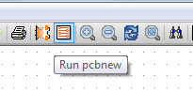
- The “Pcbnew” window will open.
- Click “OK” on the error message about the file not existing.
- Click on “File” -> “Save”.
- Click the “Page settings” button on the top toolbar.
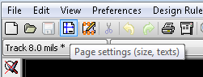
- Select “paper size” as “A4” and enter “title” as “Tute 1” .
- It’s a good idea to set your clearance and minimum track width settings to those required by your PCB manufacturer. As an example of this, we’ll set our clearance to 0.015” and our minimum track width to 0.01”.
- Click on the “Design Rules” -> “Design Rules” menu.
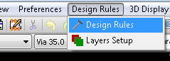
- If it’s not already showing, click on the “Net Classes Editor” tab.
- Change the “Clearance” field at the top of the window to “0.015” and the “Track Width” field to “0.01”
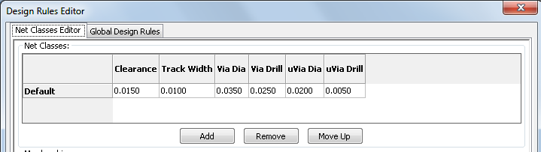
- Click on the “Global Design Rules” tab and set “Min track width” to 0.01”.
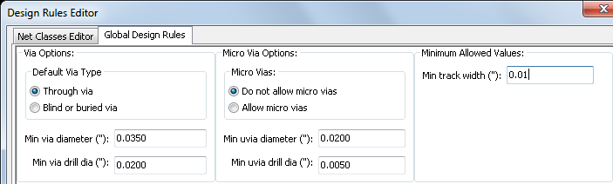
- Click the OK button to commit your changes and close the Design Rules Editor window.
- Click on the “Read Netlist” button on the top toolbar.
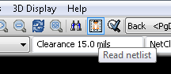
- Click the “Browse Netlist Files” button, select “tute1.net” in the file selection dialog, and click on “Read Current Netlist”. Then click the “Close” button.
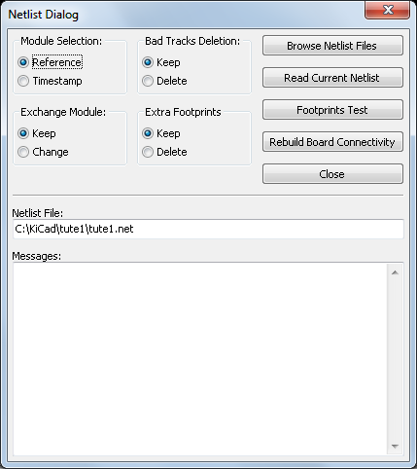
- The components will be placed in the top left hand corner just above the page. Scroll up if you can’t see them.
- Right click on a component, click on that component’s name at the top of the menu, and then click “Move”. Move the component to the middle of the board.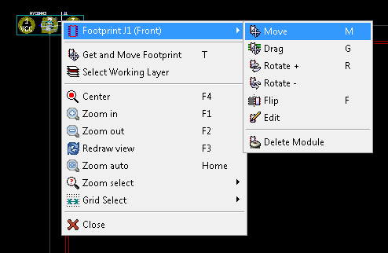
- Repeat previous step until all the components are in the middle of the page.
- Make sure that the “Hide board ratsnest” button is selected so you can see the ratsnest of wires linking the components (Note: the tooltip is backwards; pressing this button displays the ratsnest).
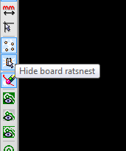
- Move the components around until you minimise the number of wire crossovers.
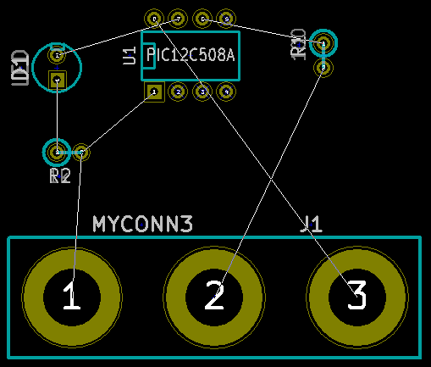
- If the ratsnest disappears or the screen gets messy right click and click “Redraw view”.
- Now we will connect up all of the wires except the ground wire on the “front” layer.
- Select “Front” in the drag down menu on the top toolbar.
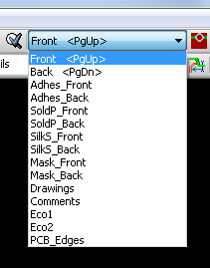
- Click on the “Add Tracks and vias” button on the right toolbar.
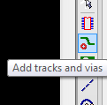
- Click in the middle of pin 1 of “J1” and run a track to the pad “R2”. Double-click to set the track’s end point.
- Repeat this process till all wires except pin 3 of J1 is connected.
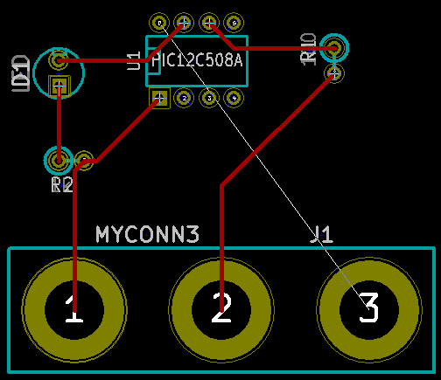
- Select “Back” in the drag down menu on the top toolbar.
- Click on “Add tracks and vias” button.
- Draw a track between pin 3 of J1 and pin 8 of U1.
- Click on “Net highlight” button on the right toolbar.
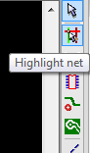
- Click on pin 3 of J1. It should turn yellow.
- Click on “Add Zones” button on the right toolbar.
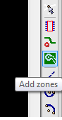
- We’re going to trace a rectangle around the board, so click where you want one of the corners to be. In the dialog that appears, set “Pad in Zone:” to “Thermal relief” and “Zone edges orient:” to “H,V”, and then click “OK”.
- Trace around the outline of the board by clicking at each corner in rotation. Double-click to finish your rectangle.
- Right click inside the area you have just traced.
- Click on “Fill or Refill All Zones”. The board should fill in with green.
- Your board should look something like this:
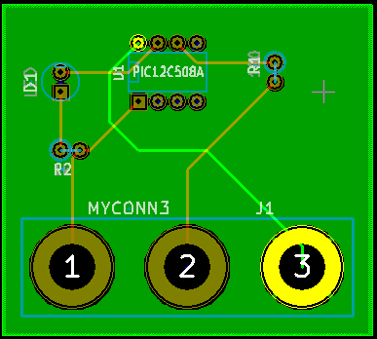

- Now select “PCB Edges” from the dropdown menu in the top toolbar.
- Select the “Add graphic line or polygon” button on the right toolbar.
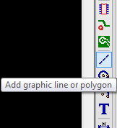
- Trace around the edge of the board, clicking at each corner, and remember to leave a small gap between the edge of the green and the edge of the PCB.
- Run a design rules check by clicking on “Perform Design Rules Check”.
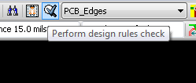
- Click on “Start DRC”. There should be no errors.
- Click on “List Unconnected”. There should be no unconnected.
- Click “OK” to close the DRC Control dialog.
- Save your file by clicking on “File” -> “Save”.
- To admire your board in 3D, click on “3D Display” -> “3D Display”.
- You can drag your mouse around to rotate the PCB.

- Your board is complete. To send it off to a manufacturer you will need to generate a GERBER file.
- Click on “File” -> “Plot”.
- Select “Gerber” as the “Plot Format” and click on the Plot button. Click Quit to close the Plot dialog.
- To view GERBER files go to the main KiCad window.
- Click on the “GerbView” button.

- On the drag down menu select “Layer 1”.
- Click on “File” -> “Load Gerber file”.
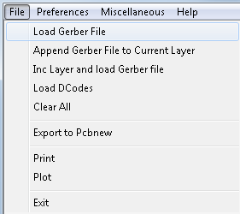
- Select the file named “tute1-Front.gtl” and then on “open”.
- Repeat steps 173 through 175, this time selecting “Layer 2” and then loading “tute1-Back.gbl”.
- Repeat steps 173 through 175, this time selecting “Layer 3” and then loading “tute1-SilkS_Front.gbo”.
- Repeat steps 173 through 175, this time selecting “Layer 4” and then loading “tute1-SilkS_Back.gbo”.
This way you can examine the layers that will be sent to production.
There is a extensive footprint library with KiCad, however on occasion you might find that the footprint that you need is not in a KiCad library. Here are the steps for creating a new PCB footprint in KiCad:
- Go back to PCBnew window.
- Click on “Open Module Editor” button on the top toolbar.
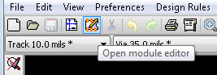
- This will open the “Module Editor”.
- Click on “select working library” on the top toolbar.
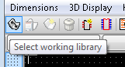
- For this exercise select the “connect” library.
- Click the “New Module” button on the top toolbar.
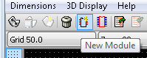
- Enter “MYCONN3” as the “module reference”.
- In the middle of the screen a “MYCONN3” label will appear.
- Under the label will be “VAL**”.
- Right click on “MYCONN3” and move above “VAL**”.
- Right click on “VAL**”, select “Edit Text Mod” and rename it to “SMD”.
- Check the “Display” value to “Invisible”.
- Select the “Add Pads” on the right toolbar.
- Click on the screen to place the pad.
- Right click on the new pad and click “Edit Pad”.
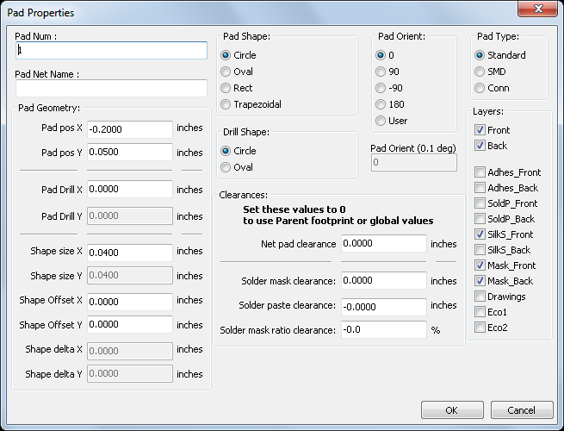
- Set the “Pad Num” to “1”, “Pad Shape” to “Rect”, “Pad Type” to “SMD”, “Shape Size X” to “0.4”, and “Shape Size Y” to “0.8”. Click “OK”.
- Click on “Add Pads” again and place two more pads.
- Move the “MYCONN3” and “SMD” labels out of the way so it looks like above.
- Click on “Add graphic line or polygon” button in the right toolbar.
- Draw an outline of the connector around the component.
- Click on “Save Module in working directory” on the top toolbar, using the default name, MYCONN3.
- You can now return to PCB new and click on “Add modules” button on the right toolbar.

- Click in the screen, and the module name window will pop-up.
- Select the module “MYCONN3” and place it on your PCB design.
This has been a quick tutorial on most of the features in KiCad. For more detailed instructions there is a detailed help file which can be accessed through all KiCad modules. Click on Help -> Contents.

